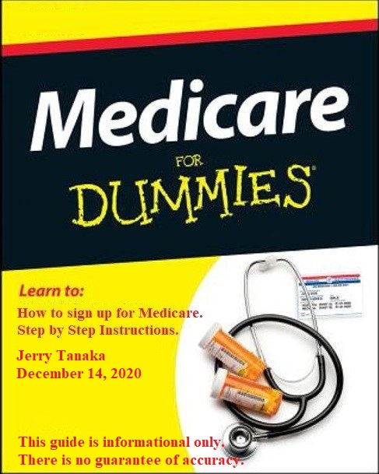
Medicare Coverage
When you're first eligible for Medicare, you have a 7-month Initial Enrollment Period to sign up for Part-A and/or Part-B.
If you're eligible for Medicare when you turn 65, you can sign up during the 7-month period that:
- Begins 3 months before the month you turn 65
- Includes the month you turn 65
- Ends 3 months after the month you turn 65

Medicare Part-A: Hospital Coverage (free for most people).
Part-A covers inpatient hospital stays and some health care.

You can apply for Part-A at age 65 without receiving Social Security
benefits by following the instructions below. If you are already receiving
Social Security benefits, then you already have Part-A (automatic).

Medicare Part-B: Medical Coverage (monthly fee).
Go to web site for Part-B costs (for 2021, standard fee is $144.50/month)
https://www.medicare.gov/your-medicare-costs/part-b-costs

Part-B covers doctor’s services, outpatient care, medical supplies and
preventive services.

NOTE: Medicare Part-A and Part-B are under Social Security Administration.

Part-C (Medicare Advantage Plan), Medigap, Part-D, E, F etc are under
private insurance companies (i.e., Aetna, Cigna, AARP, Blue Cross, etc). It
is referred as “supplemental medical insurance”.

Page-1
Supplemental Medical Insurance

After you have applied for Medicare coverage Part-A and Part-B, you can choose one of the following Option-1 or Option-2 to cover both your health and prescription drug costs.

Option-1: Medicare Advantage Plan (Part-C):
Medicare Advantage plans provide your benefits instead of “Original” Medicare, and most include drug coverage (Part-D). Monthly premiums are generally lower but you may pay more out-of-pocket costs. These plans have networks, so you'll want to check if your preferred doctors are in network.

Some things to consider with this option:
Generally lower premiums
Generally higher out-of-pocket costs
Fewer premiums; medical and drug coverage combined in one plan
Plans have networks, check if preferred doctors are in network

Option-2: Medigap Plan (Medicare Supplemental) and Prescription Drug Plan
Medigap plans help pay for out-of-pocket costs, such as copays and deductibles. These plans do not cover drugs. Monthly premiums are generally higher, but most out-of-pocket medical costs are covered. You may see any doctor that accepts Medicare.

Prescription Drug Plan (also known as Part-D)
Help pay for out-of-pocket prescription drug costs usually not covered by Original Medicare.

Some things to consider with this option Medigap plans:
Generally higher monthly premiums
Generally low to no out-of-pocket costs
Do not cover prescription drugs (Part-D)
No networks, see any doctor that accepts Medicare

Prescription Drug Plans (Part-D):
Help pay for out-of-pocket prescription drug costs not covered by Original Medicare.

For further information:
Go to the web link below to get more information on the difference between Medicare Advantage Plan and Medigap.

https://www.investopedia.com/articles/personal-finance/071014/medigap-vs-medicare-advantage-which-better.asp

Page-2
Instructions on how to apply for Medicare Part-A and B without SSA benefits

(1) Create a Social Security Account (optional, but will make life easier):
https://www.ssa.gov/myaccount/

(2) Apply for Medicare:
https://www.ssa.gov/benefits/medicare/

Open the web site, scroll down until you see “Apply for Medicare Only” and click on the blue button.

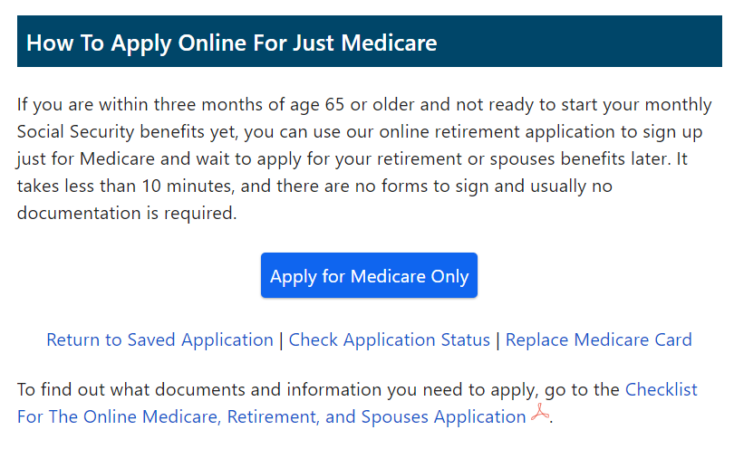

A series of panels (see numbers 1-4) will ask you various questions. If you have created a Social Security Account (see Step #1), then many of the items will already be filled out.

(A) Select “Yes” when “Enroll Part-B” is asked. Otherwise, you may pay a penalty later.

(B) You will receive a “Re-Entry” or “Confirmation Number”, see 4.
In the example that number is “12345678” … Please keep for future reference.

Page-3
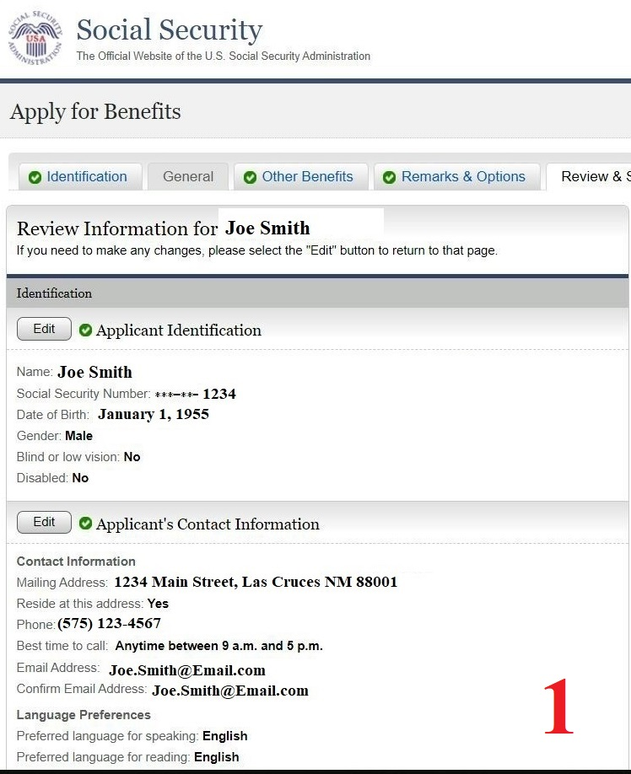

Page-4
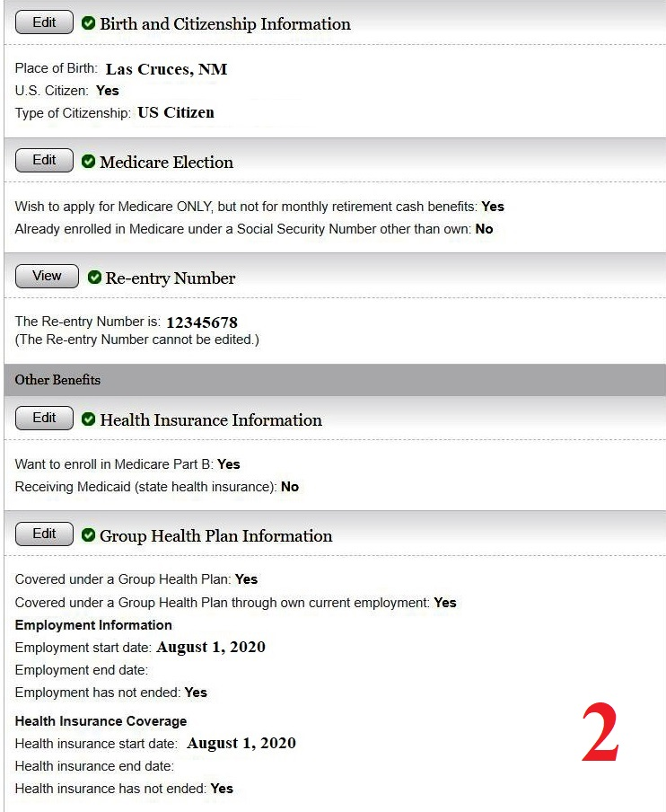

Page-5
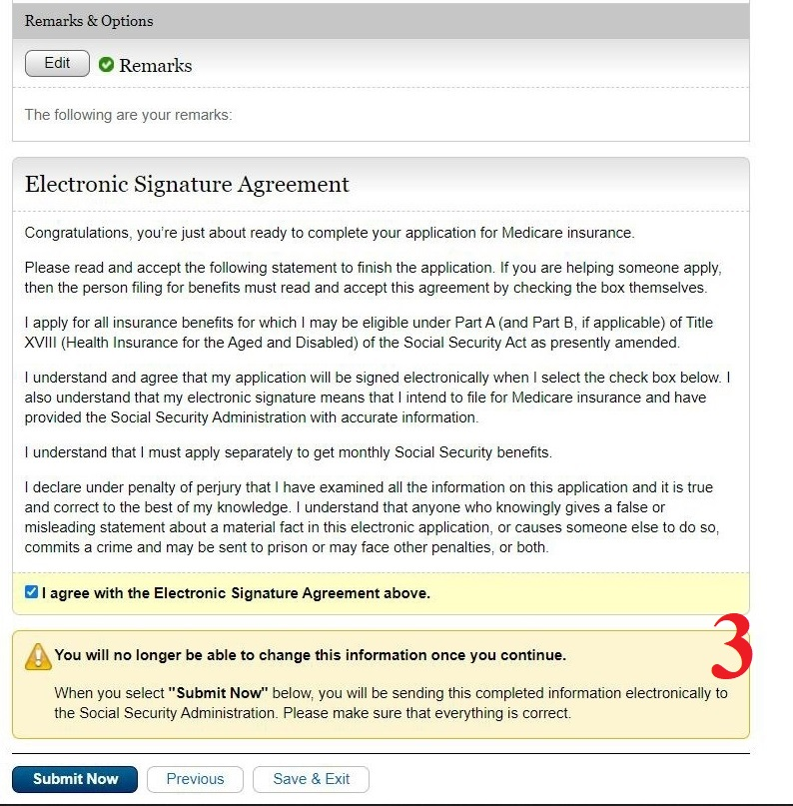

Page-6
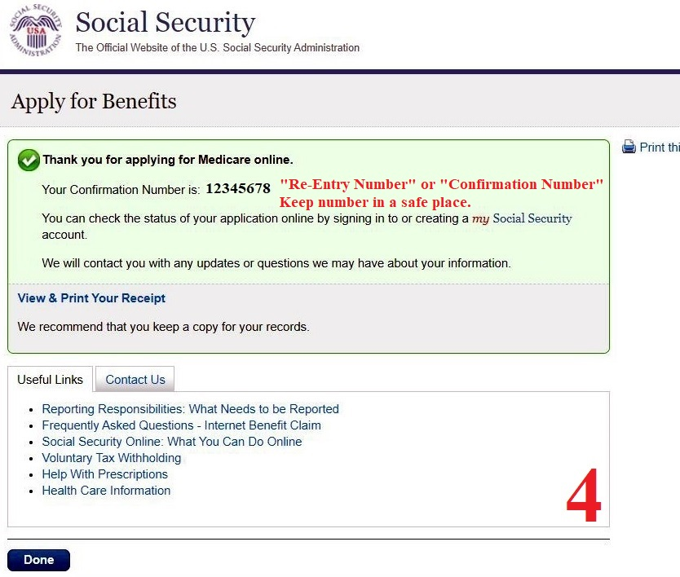

Page-7
(3) When completed, you will receive an email confirming your enrollment for Medicare Part-A and (if applicable) Part-B. You will also receive a Medicare Account Number typically in a few days from enrollment.

(4) Once you have received your Medicare Account Number (and typically you will have that number within a few days via email), create a Medicare Account/Login Page.
https://www.medicare.gov/sign-up-change-plans

(A) Once an account is created, you can order a new Medicare Card, pay you Part-B bill, etc.

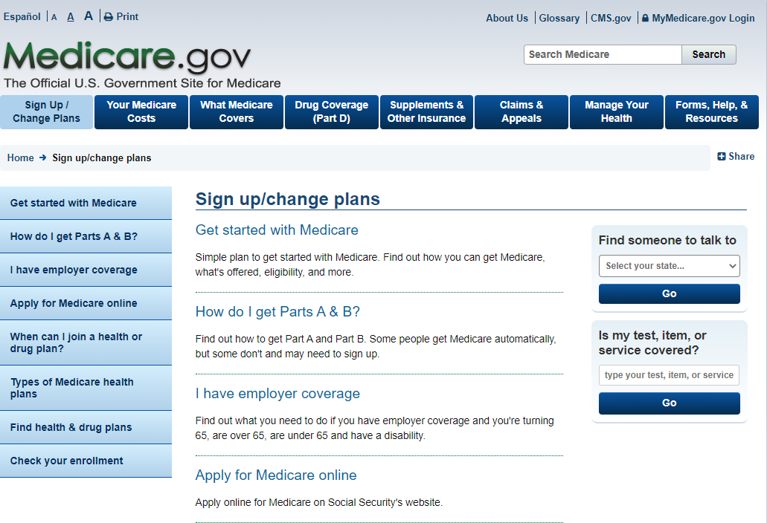

Page-8
Medicare Costs:
Medicare Part-A (Hospital) is free for most people.
Medicare Part-B (Medical) for 2021 standard is: $148.50/month

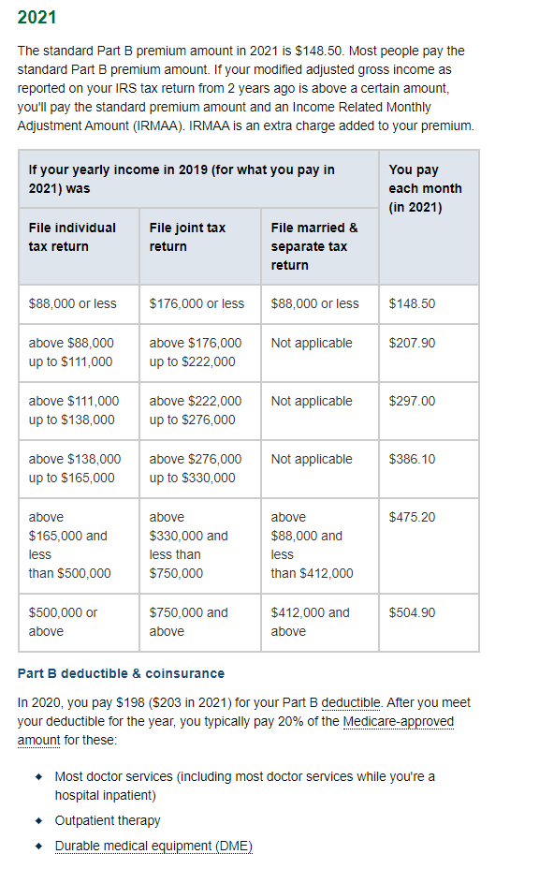
Page-9
After Medicare Part-A and Part-B, you will have to decide on Medicare Supplemental Insurance, and is provided by private insurance companies (i.e., Humana, Aetna, etc).

There are 2 different plans to choose from. Go over the insurance companies that offer the plans and choose the plan that best fits your health and lifestyle.

The choices are:
(1) Medicare Advantage Plan (Part-C, and most plans include Part-D) or,
(2) Medigap.

Go to the web link below to get more information on the difference between Medicare Advantage Plan and Medigap.

https://www.investopedia.com/articles/personal-finance/071014/medigap-vs-medicare-advantage-which-better.asp

My understanding is if you are in good health, then Medicare Advantage Plan is the better choice.

Page-10

